Software Design Specification

Introduction
This tool serves as an alternative method of determining foot traffic for businesses or individuals, and to serve as a way to collect metrics. Instead of relying on indirect methods of obtaining traffic data, such as sales, this tool will provide a way to have a better understanding of the actual number of people in a specified area. The advantage that this brings is that it can also measure persons who do not interact directly with the services being provided by the business. For example, a business may only have 35% of the people entering its venue make a purchase – but the sales figures only show metrics for that 35%. A business can use this tool to increase the level of interaction with the products and services that it offers. The most important feature that this system offers is data collection and visual representation of that data.
Architecture
The type of system that will be used will be server + sensors. That means that there will be sensors (Raspberry Pi’s) that the server connects to and retrieves the information from. The server can either be hosted locally, or in the cloud, depending on the specific requirements of the deployment. The only task that the sensors must do is collect data in real time, and then the server will fetch the data through an SFTP connection. At the server level, the data will then be processed and displayed in set intervals (e.g. every 10 minutes it will process the data collected). The web management page will display the data available at the time of opening it. Ideally, the system will only be accessed and configured through a web management interface for all major functions past the initial setup. The main inputs are from the sensors (nodes), which are MAC addresses in range of the data collector. The main output is the processed data that has been collected.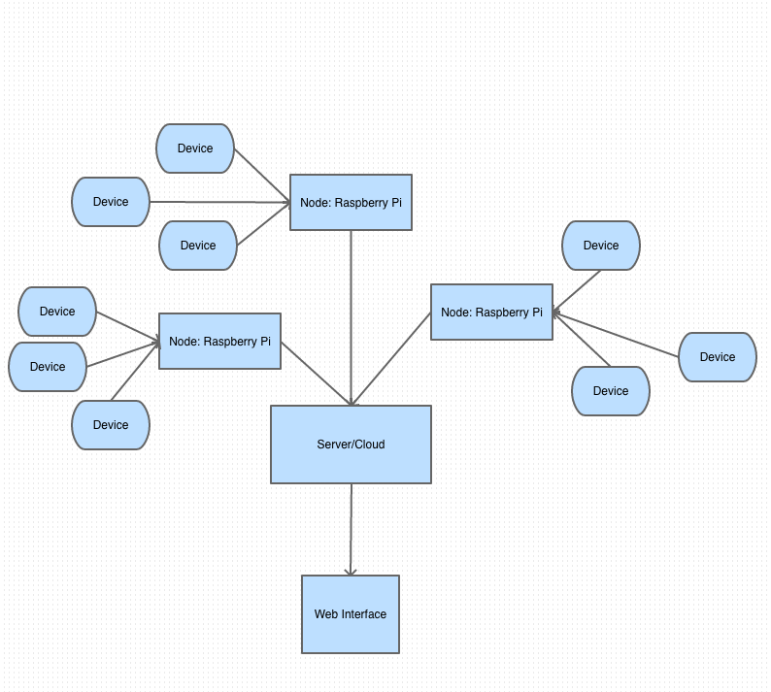

Use Cases
Use Case 1 – Viewing collected information

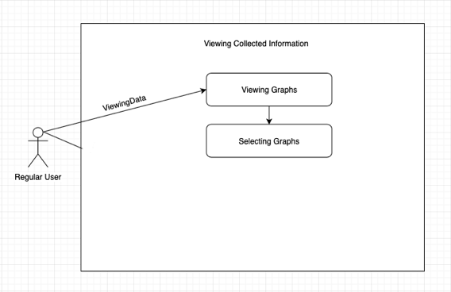

1.1 - The user navigates to the web management home screen. By default, there is only one default area, so the graphs for the data for that area will be shown first, as well as basic statistics. If there are other areas configured, the user will be able to select which area is visible at the top of this main page.

Use Case 2 – Adding and configuring a tracking “Node”

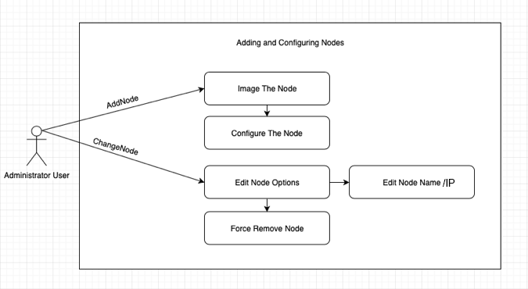

2.1 - An administrator user wishes to add another tracking node. First, the node itself must be configured before it can be added. The user must first image the node with the base image provided. The configuration file is then updated with the proper Wi-Fi network connection information that will be used in the physical location where the node is placed, as well as assigning a name and IP address. The node name and IP address must then be added in the “Node Configuration” page.

2.2 - A user wishes to change the identity of the node. The user clicks on the menu, then clicks on the “Node Configuration” selection. From here, it is possible to select the name of the node which will redirect to a specific page for that node. The name of the node and IP address of the node can then be changed. Once the user saves these options, the server will update the saved configuration of the node.

2.3 - A user decides to change the name of a node once it has been deployed. The user clicks on the menu, then clicks on the same node configuration selection. There is an option to change the name of the node. Once the user saves the new name, the server will update the configuration of the node.

2.4 - It may be desired that a node be removed. The user clicks on the main menu, then clicks on the “Node Configuration” selection. The user then clicks on the name of the node, and once on the page for that node, can select “Remove Node”. The server will then remove the node from the list of recognized nodes. The user will then have to manually reconfigure the node.

Use Case 3 – Configuring data collection for different areas

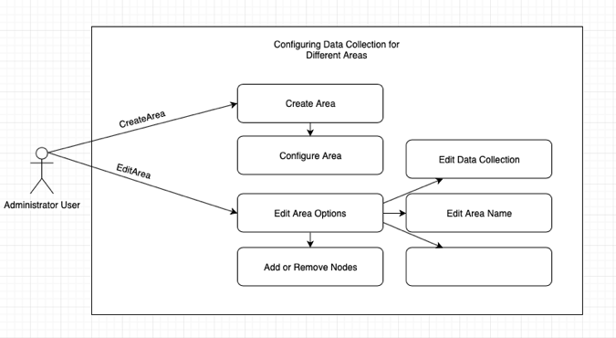

3.1 - By default all nodes will have their data collection merged together and represented as one big area. A user decides that different nodes physically located in different areas should have their data represented separately from each other. The user clicks on the main menu, then clicks on the “Area Settings” selection, then on “Create Area”. The user is then prompted to enter a name for the area, and can select nodes that have not been assigned a specific area yet. Once the entry is saved, the main management page will be updated to show statistics for the new area.

3.2 - A user would like to remove or edit an area’s name or nodes. The user clicks on the main menu, then clicks on the “Area Settings” selection, then on the area they would like to edit. There is the option to edit the name of the area, add or remove nodes, or to delete the area. Once the changes are saved, if the area is deleted or nodes are removed, the nodes will be moved back into the default area. The changes will then be reflected on the main management page.

3.3 - Beyond the default data collection (Number of people detected over an interval of time); the user can configure other data collections for an area. The user selects the main menu, clicks on “Area Settings”, then on the area they would like to edit. The user can then select different types of data collection (e.g. Average length of time a person is detected in that area), and save their selection. The changes will then be reflected on the main management page.

Use Case 4 – Linking areas

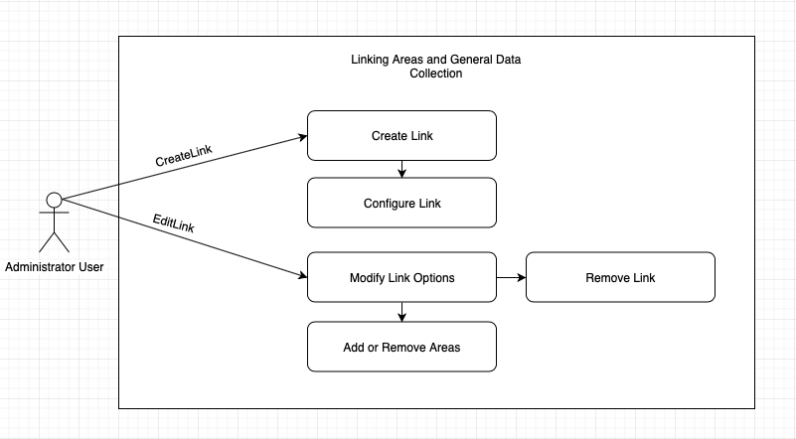
4.1 - A user may wish to compare different areas. They may do so by “linking” two or more areas. The user navigates to the main menu and selects “Area Linking”. From here, the user selects “New Link” and can choose from a list of unlinked areas. By default, only the common statistics that both areas are already collecting will be compared. The user may also have the option to select additional statistics such as percentage of people found in one area that are also found in the other area. Once the link is saved, there will be a new option on the main management page to show the new statistics.

4.2 - A user may also wish to “un-link” areas, or modify a link. They may do so by navigating to the main menu, selecting “Area Linking”, then “Edit Link”. Then the user may select the link they wish to modify, and can select either “Add or Remove Areas”, or “Remove Link”. If a user selects “Add or Remove Areas”, they will then have the option to add an available area or remove an existing area. If the user selects “Remove Link”, the link will be removed. Once the changes are saved, the changes will then be reflected on the main management page.

Use Case 5 – Administrative Functions

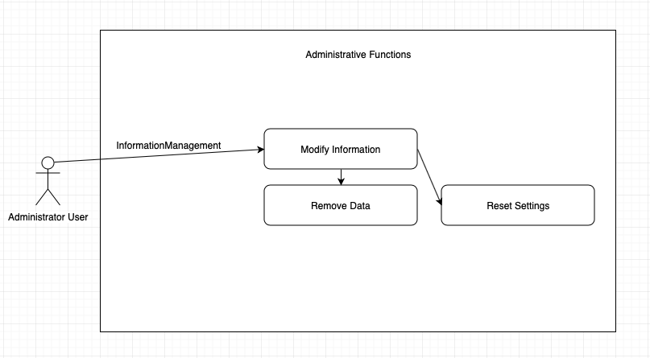

5.1 - Deleting or reset collected data. The administrator account has the ability to delete old data, or completely reset all data collected. The user clicks on the main menu, clicks on “Settings”, “Delete Data”. They then have the option to either click “Delete All Data”. Once the option is selected, the user will be prompted with a “Are you sure you want to continue?” warning, then once accepting the risk, the data will be deleted permanently.

5.2 - Resetting settings to default. If desired, all settings can be reset to the default state without deleting any information. The user clicks on the main menu, clicks on “Settings”, “Reset Settings to Default”. Once the option is selected, the user will be prompted with a “Are you sure you want to continue?” warning, then once accepting the risk, the settings will be returned to default.

Structural Design

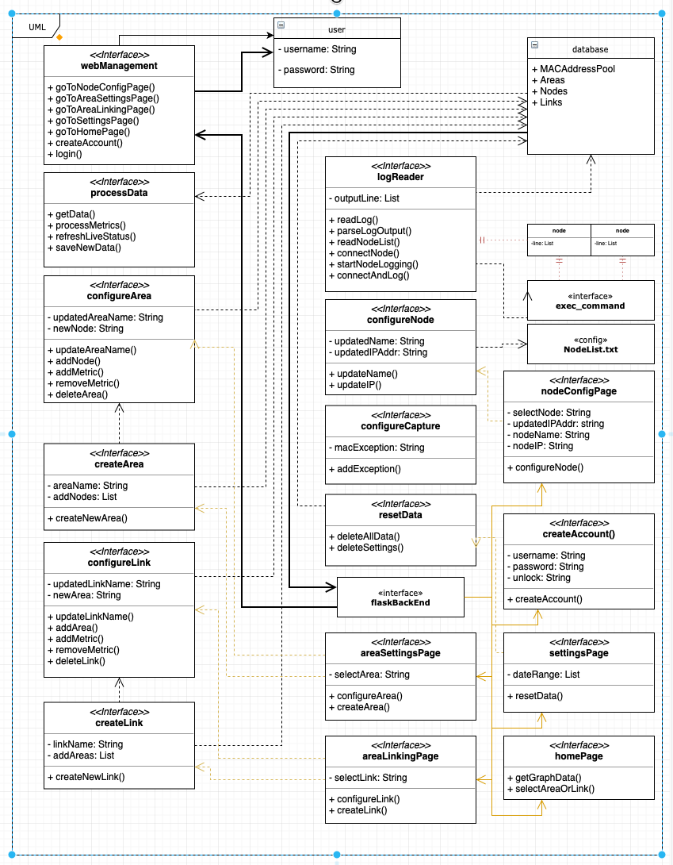

Data

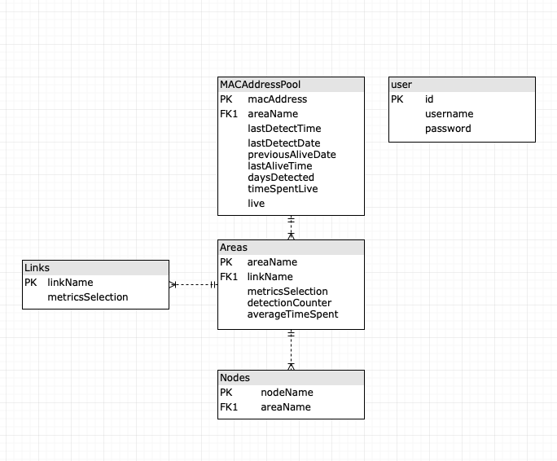

User Interface Design

Viewing Information

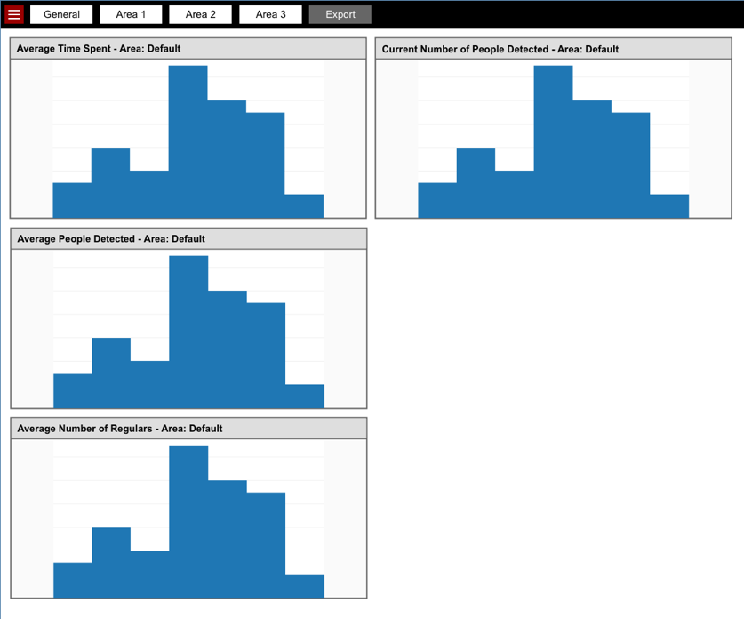

Configuring a Tracking Node

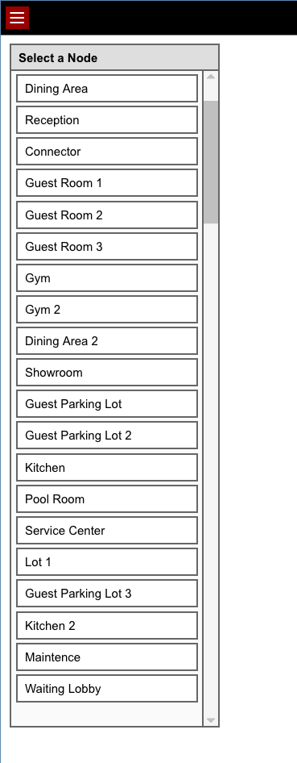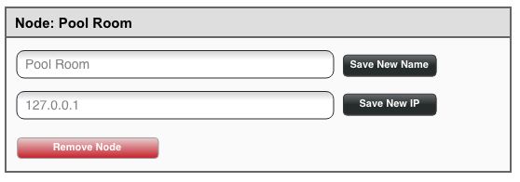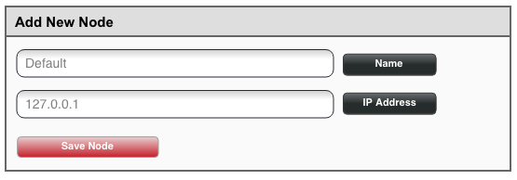

Configuring Data Collection for Different Areas

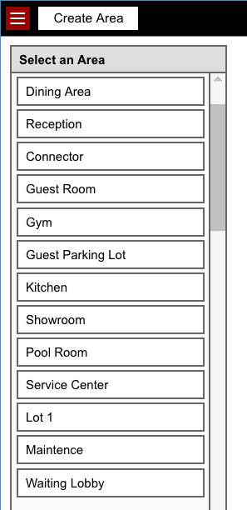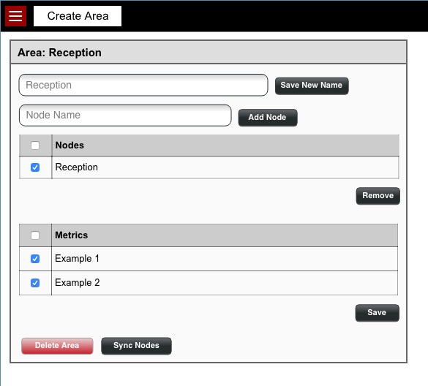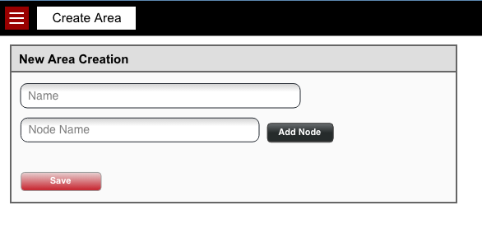

Linking Areas

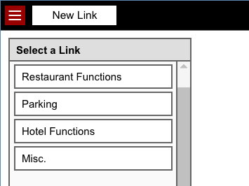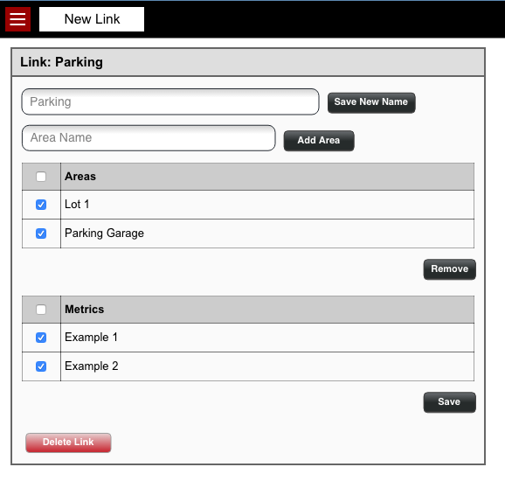
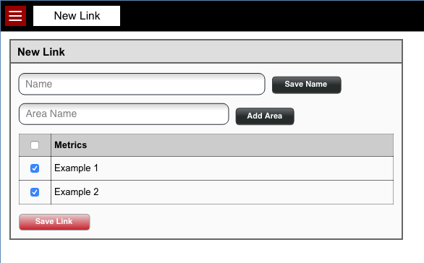
Administrative Functions

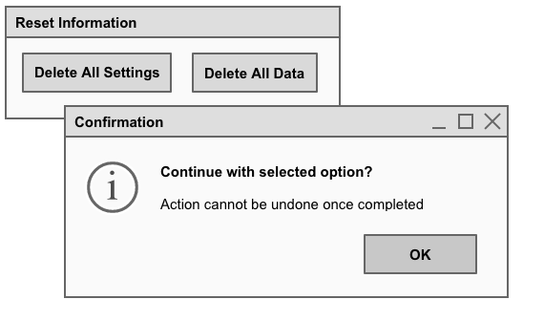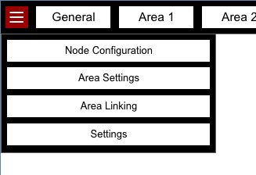

Workplan
